|  |  |
| --- | --- |
| j0334580 | **Story of Self Workshop:**  Story of Self Practice |
|  |  |

**GOALS**

* Learn the basics of telling your Story through “Story of Self"
* Practice telling your Story of Self and get constructive feedback
* Learn to draw out and coach the stories of others

|  |
| --- |
|  |

**Facilitators: Read below to ground yourself in the training.**

***By telling a “story of self” you can communicate the values that move you to lead.*** Effective communication of motivating values can establish grounds for trust, empathy, and understanding. Telling our story of self can help establish firm ground for leadership, collaboration and discovering common purpose.

Every one of us has a compelling story of self to tell. We all have people in our lives (parents, grandparents, teachers, friends, colleagues) or characters we love, whose stories influence our own values. And we all have made choices in response to our own challenges that shape our life’s path— confrontations with pain, moments of hope, calls to action.

The key focus is on our choices, those moments in our lives when we our values moved us to act in the face of challenge. When did you first care about being heard? When did you feel you had to act? Why did you feel you could? What were the circumstances, the place, the colors, sounds? What did it look like? The power in your story of self is to reveal something of those moments that were deeply meaningful to you in shaping your life—not your deepest private secrets, but the events that shaped your public life. Learning to tell a good story of self demands the *courage of introspection*, and of sharing some of what you find.

### The Three Key Elements of Story of Self Structure: Challenge, Choice, Outcome

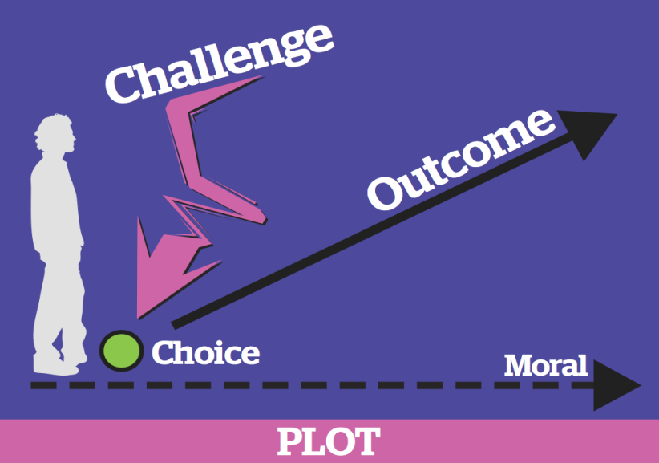

A plot begins with a challenge that confronts a character with an urgent need to pay attention, to make a choice for which s/he is unprepared. The choice yields an outcome, and the outcome teaches a moral.

Because we can empathetically identify with the character, we can “feel” the moral. We hear “about” someone’s courage; we are also inspired by it.

The story of the character and their choices encourages listeners to think about their own values, and challenges, and inspires them with new ways of thinking about how to make choices in their own lives.

***Incorporating Challenge, Choice, and Outcome in Your Own Story***

There are some key questions you need to answer as you consider the choices you have made in your life and the path you have taken that brought you to this point in time as a leader. Once you identify the specific relevant choice, dig deeper by answering the following questions.

***Challenge:*** Why did you feel it was a challenge? What was so challenging about it? Why was it your challenge?

***Choice:*** Why did you make the choice you did? Where did you get the courage (or not)? Where did you get the hope (or not)? Did your parents or grandparents’ life stories teach you in any way how to act in that moment? How did it feel?

***Outcome:*** How did the outcome feel? Why did it feel that way? What did it teach you? What do you want to teach us? How do you want us to feel?

**AGENDA**

**UP FRONT TRAINING:**

**Son Ah/Jeanie will train up front for 20 minutes explaining Story of Self 25 min.**

* Do quick introductions (name & hometown) & Share Goals – 3 min (*Jeanie)*
* Tell Own Story – 5 min (*Jeanie)*
* Training Content (Flip Chart or PPT) (*Son Ah)* – 15 min (*Son Ah)*
  + Review Content
  + Tell Own Story – 5 min *(Jeanie)*
  + Get Feedback on Challenge, Choice & Outcome
* Explain Partner Exercise – break up into partners – 2 min (*Jeanie)*

**Partner Exercise:** *(Facilitator – Jeanie)*

**TIME:** 50min.

|  |  |  |
| --- | --- | --- |
|  |  |  |
| **1.** | **Develop your “Story of Self”**  Take some time to **silently develop your “Story of Self,**” using the worksheet that follows. | **10min.** |
| **2.** | **Work with a partner to practice telling your Story** **of Self.**  Explain What it Means to Coach (review to “Coaching Tips”):  For each person:   * 2 minutes each to tell your story:   + Focus on the values you want to convey and the experiences that shaped you.   + Be specific & give lots of details. * 3 minutes each for feedback:   + Use the “Coaching Tips” worksheet to help guide your feedback.   + What **values** did the storyteller convey? How specifically?   + What is the **Challenge**, **Choice**, **Outcome** in each story?   + Were there sections of the story that had especially good details or images (sights, sounds, smells, or emotions of the moment)? | **10min.** |
| **3.** | **Revise your Story of Self.**  Based on the feedback you got from your partner, take some time as individuals to make revisions and adjustments to your story of self. | **5 min.** |
| **4.** | **As a team, go around the group and tell your Story of Self one by one.**  For each person:   * 2 minutes to tell their story * 2 minutes to for feedback:   + Were there elements of the story that were really strong or could be improved?   ***NOTE:*** You have just 2 minutes to tell your story. Stick to this limit. Make sure your timekeeper cuts you off. This makes sure everyone has a chance to tell their story. | **20min.** |
| **6.** | **Wrap-Up** | **5 min.** |