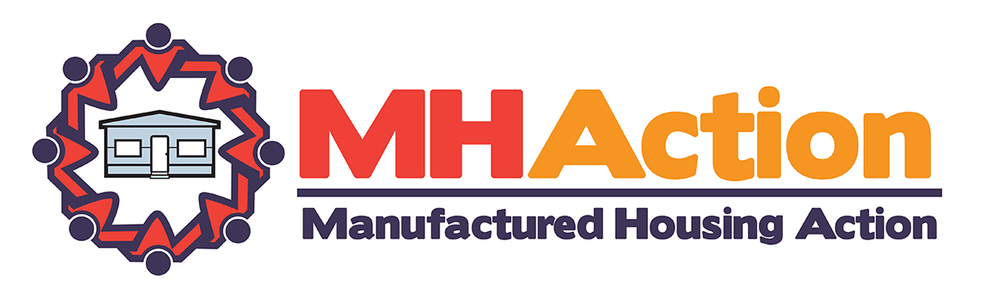
# SAMPLE PRESS RELEASE FOR LOCAL PRESS WORK #

Enter Date

Contact: Enter contact information (Name and location)
Contact Info: Enter Email and Phone

Manufactured Homeowners Across the County Demand Equity Lifestyle Properties, Inc. (ELS) Improve Their Customer Relations Process

Community Survey Exposes ELS’s Lack of Commitment to Disseminate Clear Guidelines for Homeowners to Raise Issues and Concerns

Washington, DC – Homeowners from across the country are calling upon Equity Lifestyle Properties, Inc. (ELS) to follow thru on their commitment to disseminate clear guidelines involving their complaint process. In May of 2016, at an ELS’s shareholder meeting in Chicago, Illinois, ELS company executives reiterated their 2015 agreement with homeowners that live in ELS-owned communities to communicate a clear and concise customer complaint process. The goal of the complaint process would be to provide easy-to-follow guidelines for the 140,000 plus homeowners living in ELS-owned communities to raise issues or concerns.

“We surveyed forty-four (44) ELS-owned communities in fourteen (14) states in June and July, and found only one community, where the majority of respondents expressed familiarity with ELS’s customer complaint process,” stated ______________________ a homeowner from_____________. “It is abundantly clear given 88% of all responses that were received by MHAction indicated no customer knowledge of ELS’s complaint process, that ELS has not followed thru on communicating that process to homeowners, like myself. For a company the size of ELS, that is worth billions of dollars, not having a clear customer complaint process is extremely puzzling and disturbing.”

ELS is the nation’s largest corporate owner of manufactured home communities with 380 manufactured home communities (defined as land-lease communities) in 32 states. Homeowners across the country that live in manufactured home communities are growing increasingly concerned as community ownership has shifted from “mom and pop” enterprises to ownership by large, multi-state corporations, like ELS. Many homeowners involved with MHAction feel the increase of multi-state, corporate ownership has brought with it an unsustainable business model that is based on rapidly escalating lot fees and decreasing investments in community infrastructure. This creates an economic trap for homeowners, who are usually unable to move their home for structural or regulatory reasons and therefore must either pay increasingly high lot fees or abandon their property.

“It is infuriating that a company that makes millions off of monthly rent paid by seniors is unable to communicate a clear customer complaint process,” added _____________, a homeowner from an ELS Community _______________. “This has left many homeowners, especially seniors like me, with a feeling of abandonment. I wonder if ELS’s investors understand how this places the company at reputational risk with its paying customers.”

Manufactured homeowners across the country are banding together and calling upon ELS and other manufactured home community owners to re-evaluate their business model and management practices. Beyond demanding the articulation of a clear customer complaint process, homeowners have requested fair and balanced rent increases that tie increases to the Consumer Price Index (CPI), standards and transparency around capital improvement plans and first right of purchase for homeowners in the event a community is sold. Additionally, homeowners believe ELS and other companies would be able to engender a higher level of customer loyalty by supporting policies that protect and strengthen the economic security of manufactured homeowners. Thousands of manufactured homeowners rely on program’s such as Social Security in order to pay their monthly lot fees. Community owners should be working side by side with homeowners to protect the programs that allow residents to cover monthly expenses.
MHAction’s mission is to engage and empower manufactured home owners that live in manufactured home communities (trailer parks) to build and win local, state and national campaigns that protect and strengthen the long-term viability and affordability of their communities. MHAction believes that manufactured home communities play a key role in rural and exurban communities across the nation in providing affordable, safe and accessible housing for all. For more information go to http://mhaction.org or contact Kevin Borden at 202-360-8876 to set up interviews with manufactured homeowners who are leading the campaign.
###

