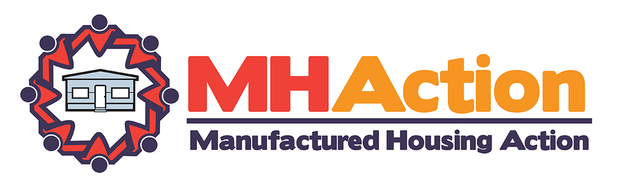

Ms. Marguerite Nader, Chief Executive Office
Equity LifeStyle Properties, Inc.
Two North Riverside Plaza
Chicago, Illinois 60606

Dear Ms. Nader,

As shareholders of Equity LifeStyle Properties, Inc. (ELS) and as manufactured homeowners that are involved with MHAction, we are calling upon ELS management to follow thru on their stated commitment to disseminate clear guidelines to all ELS homeowners involving ELS’s customer complaint process. After surveying 44 ELS communities in 14 states, MHAction has collected data that clearly indicates ELS has failed to follow thru on a stated commitment to disseminate clear and concise guidelines to all homeowners.

Following the annual shareholder meeting in May of 2015 and in May of 2016, ELS company executives agreed to remain after the official closing of the annual shareholder meeting to discuss ongoing concerns with a representative body of homeowners from numerous states. We appreciate ELS’s willingness to have an open an honest dialogue about concerns that numerous homeowners have raised in terms of ELS’s business practices. We have routinely discussed four overall items during those meetings, which include:
- Enacting a company-wide policy that creates fair and balanced rent increases by tying increases to the Consumer Price Index (CPI),
- Establishing standards and transparency around capital improvement plans,
- Articulating and disseminating a clear customer complaint process,
- Increasing customer loyalty by supporting policies that protect and strengthen the economic security of manufactured homeowners. Community owners, like ELS, should be working side by side with homeowners to protect and strengthen programs, like Social Security, that allow residents to cover monthly expenses.

After discussing these four areas, we felt a clear level of agreement was reached with ELS executives that the company would disseminate clear guidelines to all homeowners on an annual basis clarifying the steps to take with which to raise concerns and complaints. In May of 2016, ELS executives even produced documents that pertained to two specific communities, Westwood Village in Farr West, Utah and Carriage Cove in Daytona Beach, Florida.

After announcing this agreement to MHAction’s email list and on MHAction’s Public Facebook Page, numerous homeowners shared comments and feedback with MHAction about being unaware of the process. MHAction, a national non-profit dedicated to building the voice of manufactured homeowners to ensure that manufactured housing remain a safe, accessible and affordable housing option, created a survey asking homeowners if they were knowledgeable of ELS’s customer complaint guidelines. MHAction surveyed 44 communities in 14 states. Our findings paint a stark reality that clearly points to ELS’s inability to sufficiently inform homeowners of this process. In only 1 of the 44 communities did a majority of respondents indicate knowledge of the process. In terms of individual responses, 88% of all respondents answered in the negative as to knowledge of ELS’s complaint process.

In our opinion, given ELS’s size and monetary value as a company, we are extremely puzzled by ELS’s ongoing inability to inform customers and disseminate clear guidelines to follow to effectively raise concerns and complaints. ELS’s inability to disseminate this process unnecessarily increases the level of distrust and miscommunication between the company and its loyal, paying customers that MHAction finds all too common. As investors, we are concerned about the unnecessary reputational risk this potentially creates for the company by not communicating with its customer base and with potential customers.

MHAction is recommending that ELS enact the following mechanisms to ensure company-wide knowledge of the guidelines related to ELS’s customer complaint process. Those recommendations include:
- An annual mailing that is sent to all ELS homeowners outlining the process. This is a relatively inexpensive and easy task for a company the size of ELS to undertake.
- Posting of the complaint process in a central and visible location in every ELS-owned community.
- A mandatory annual meeting (conference call, webinar, etc.) of regional and local community managers reviewing the customer complaint guidelines and process.
Following these steps would help to create clear lines of communication between homeowners and the company.

We look forward to your response regarding these matters. Should you have any questions or concerns, we encourage you to address any correspondence electronically to info@mhaction.org.

Signed by the following May 2016 ELS Annual Shareholder Meeting Participants,

Connie McIff Hill
Richard and Sondra Robinson
Dale and Kathy Muzzy
Patti Rose
Shandra BP-Weeks
Kevin Borden

Cc: Equity LifeStyle Properties, Inc. Board of Directors

