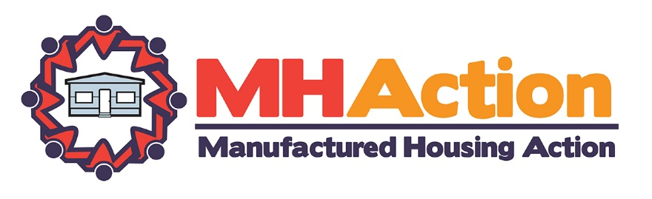

Organizational Statement on MHAction’s Values and Operating Principles

Values
MHAction staff and community leaders believe that in order to win campaigns that make concrete improvements in the lives of manufactured homeowners and create a just world to ensure our families and communities can thrive, the foundation of our organization must derive from a shared agreement on our values and operating principles.

The work of MHAction is based on a set of core values, central to which are compassion for our neighbors and love of our communities. MHAction believes that manufactured home communities play a key role in providing affordable, safe and accessible housing for all families. Across the country manufactured homeowners are seeing firsthand the problems that arise when corporate community owners prioritize their own profits and the desires of investors over the needs of those who live in the communities. MHAction believes we must unite and organize across class, race, religion, age, citizenship status, sexual orientation and gender differences to fight back and prioritize the needs of our communities. We are strongest in our fight to improve conditions in are communities and for just economic policies when we are united across our differences. Similarly, we are strongest when we do not allow personal differences or quarrels to distract us from our mission of winning concrete improvements in the lives of all manufactured homeowners. MHAction staff and Core Team Leaders believe in open and honest dialogue and in treating each other, and all members of our communities, with dignity and respect. MHAction staff and leadership infuse these values into the core programmatic work of the organization.

Operating Principles of MHAction Core Team Leaders and Staff
- To ensure that MHAction keeps true to its values of being a leadership led and directed organization that builds the power of manufactured homeowners and residents to create concrete improvement in their lives;
- To provide strategic vision and oversight of the organization.
- To take direction from MHAction Campaign Leaders and Activists regarding programmatic, tactical and policy decisions, consistent with the mission and values of the organization.
- To embrace the diversity of our communities and support the leadership of homeowners of differing race, class, gender, age, religion, citizenship status and sexual orientation and identity.
- To financially support the work of MHAction by a) making a donation of minimally $24/year to either an online strategic fundraiser or MHAction general support drive and b) recruit a minimum of 5 online donations of a minimum of $24 to either a strategic fundraiser or a local membership drive. In order to attend national MHAction-sponsored events, Core Team Leaders must be in good financial standing, as described above.

Statement of Commitment of MHAction Core Team Leaders and Staff

To create a strong and supportive organizational environment and culture, I understand, as a Core Team Leader or Staff Member that:
- I am a member of a collaborative leadership team;
- I am responsible for oversight of the organization;
- I respect the views of others and will communicate positively and respect the collective decision making of the Core Leadership Team;
- I pledge to hold myself accountable to this agreement and will strive to operate in accordance with the principles outlined above.

Signed _________________________________________ Date: _________________

